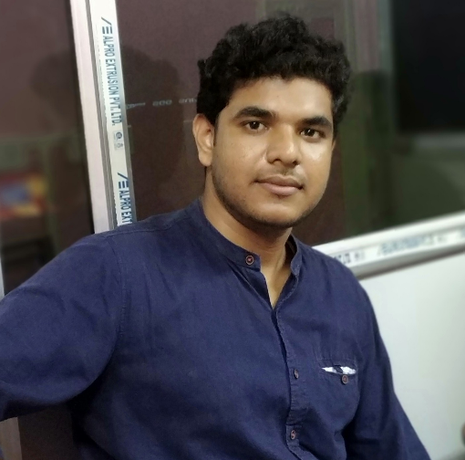**Souvik Ray**

Department of Chemistry

Indian Institute of Technology Kharagpur

Kharagpur, West Bengal, INDIA – 721302

**Email id:** [souvikray94@gmail.com](mailto:souvikray94@gmail.com)

**Phone:** 8116795566

**Research Interest:**

Designing and synthesis of new PPGs, PAGs and PBGs.

**Background:**

B.Sc. (2012-2015) - Midnapore College (Vidyasagar University)

M.Sc. (2015-2017) - Indian Institute of Technology Guwahati

**Fellowship:**

Institute fellowship (2018)